Gr4 Mod6 Topic A Quiz

1. Write the length of the bug in centimeters. (The drawing is not to scale.)
Fraction form: __________ cm

Decimal form: __________ cm

How far does the bug need to walk before its nose is at the 1 cm mark?

_________ cm

2. Match each amount expressed in unit form to its fraction form and decimal form.
3 tenths | $\frac{7}{10}$ | 0.9
7 tenths | $\frac{9}{10}$ | 0.3
9 tenths | $\frac{3}{10}$ | 0.7

3. Write the decimal that represents the shaded amount of this rectangle.
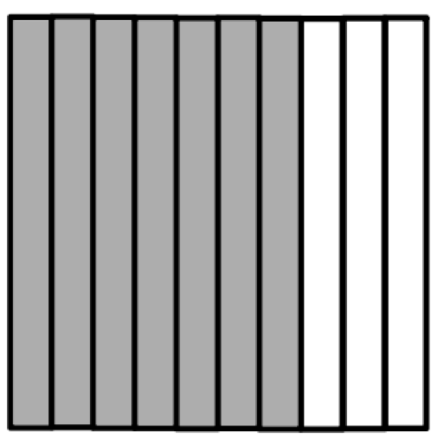

4. Write the following as equivalent decimals. Then represent the decimal by shading in the model.

a. 2 ones and 6 tenths = __________
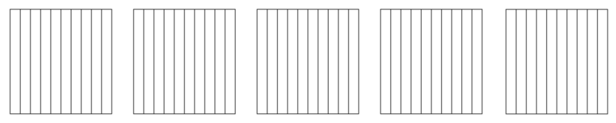

b. $3\frac{4}{10}$ = _______________

c. $\frac{21}{10}$ = ______________

5. Complete the chart.
Point | Number Line | Decimal Form | Mixed Number (ones and fraction form) | Expanded Form (fraction or decimal form) | How much to get to the next one?
a. |  |  | $8\frac{7}{10}$
b. |  | 56.3

